**INSTALLATION OF VS CODE**

To install VS code in a PC, the pc need to have 1.6 GHz or faster processor, 1 GB of RAM and minimum 500mb of storage. These are the stape to take so that you download and install VS Code to your PC.

1. Open browser of your choice and type “vs code download on your search bar on search engine.
2. Open the first link that you see

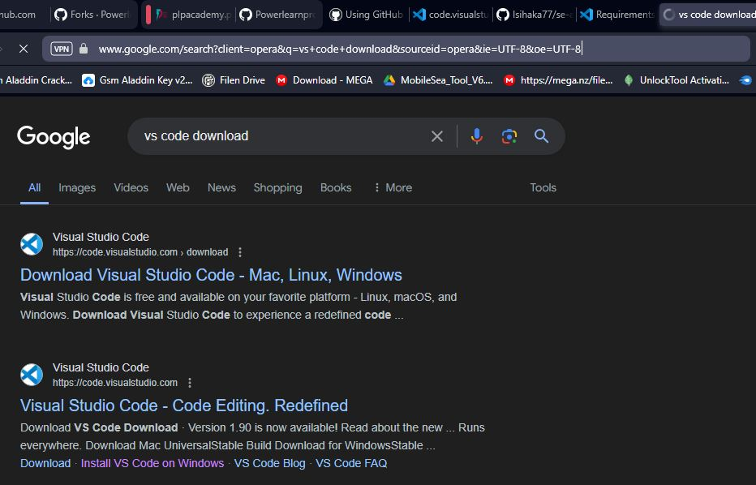

1. Choose the type of OS that you are using on your PC and click.

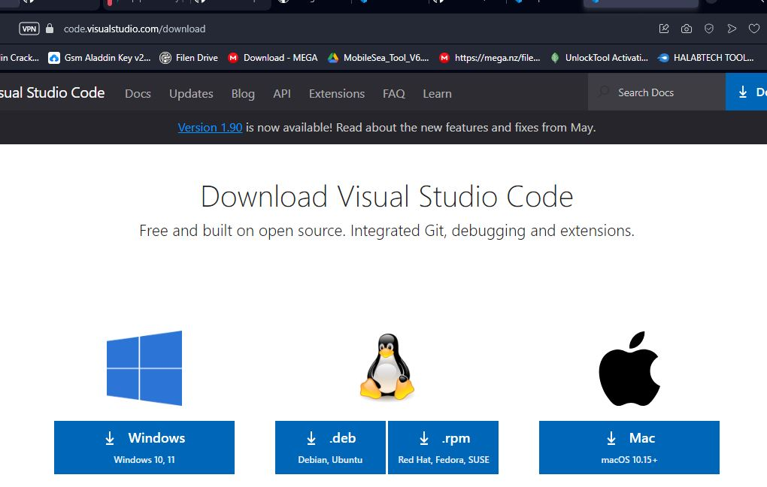

1. The download of your application will start also new wensite will open for documentation and getting started

.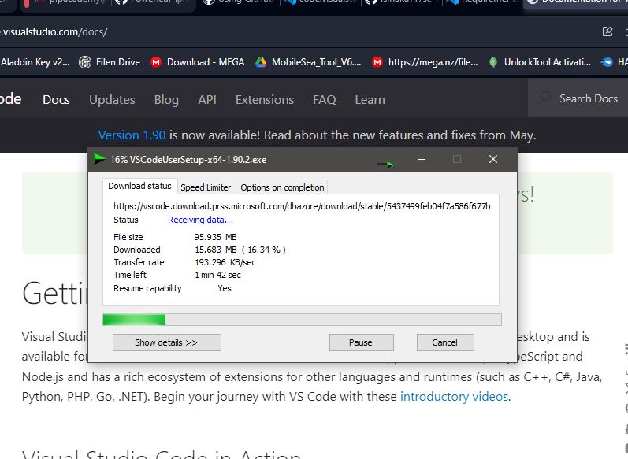

INSTALLATION

1. Open application and accept license agreement and click next.

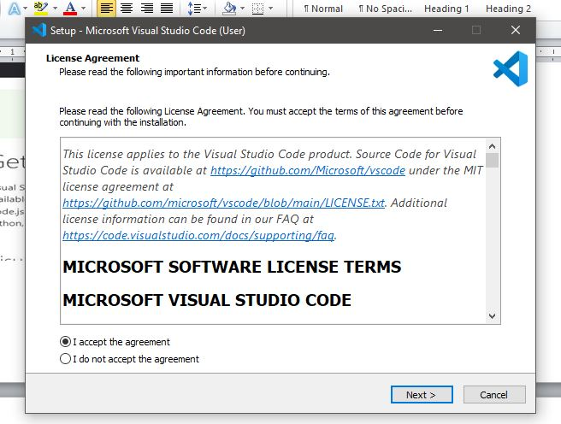

1. Choose some useful additional task for vs code.

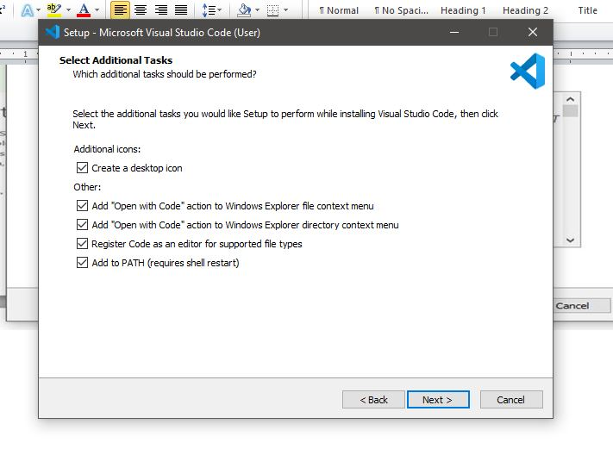

1. On ready to install just click install button and wait for installation.

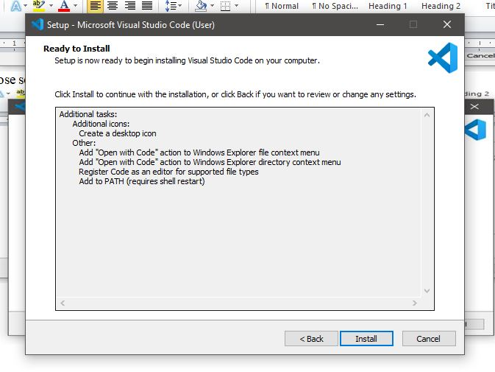

1. Because we want to open the application click the finish and lunch the application

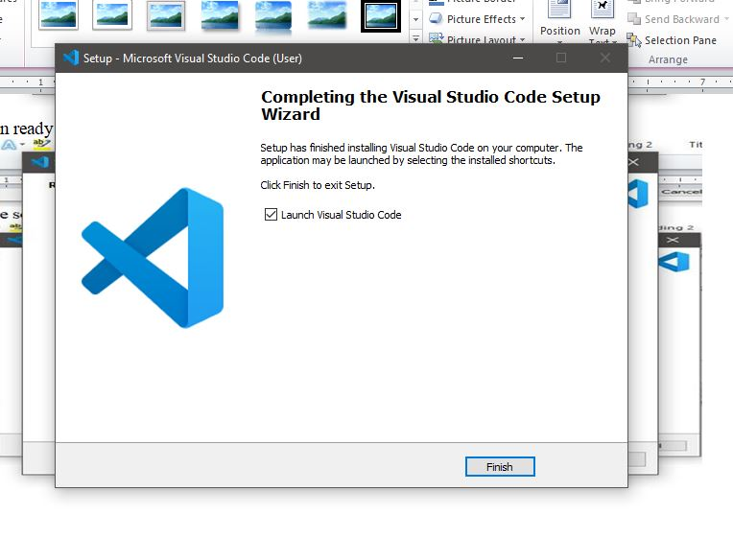

FIRST TIME SETUP.

After installing vs code for the first ime. It will have beautiful view by default but you a user can install different extension to support the kind of project you are doing like, python, django,doc/pdt viewer, gitlens and son on.

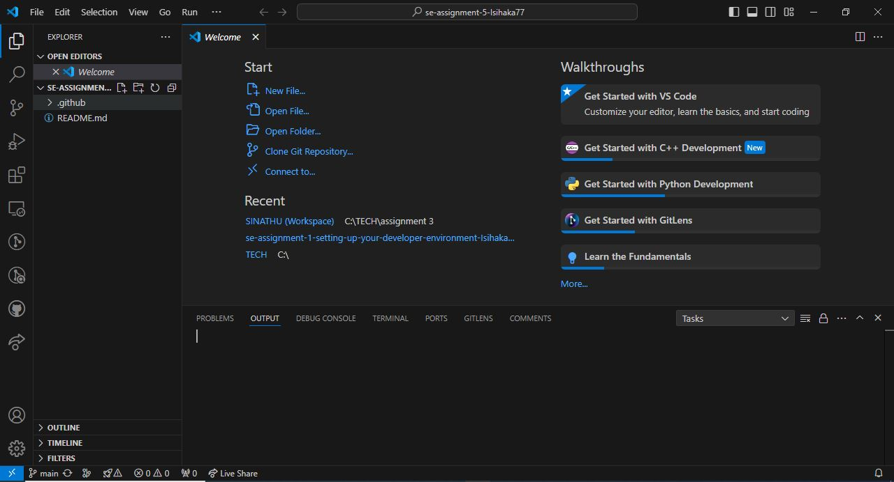

**USER INTERFACE OVERVIEW**

1. activity bar on the left that contain the following things by default
2. **Explorer** that allow user to see opened files and folders
3. **Magnifying glass**  that help in find replace text, files across working space
4. **Source control**  to track changes in code with git and github
5. **Run or debug** that help in executing code and debug it line by line using breakpoints.
6. **Extension**  that add additional feature to Vs code
7. **Last**  a place to manage our Account and setting
8. Status bar at the bottom that contain
9. Error and problem icon
10. Name of the branch
11. Current line that you are typing
12. Current programing language and and so on



**COMMAND PALETTE**

These is control center for all command in Vscode. There are two way that can be used to acces command palette. First is by shortcut “ctrl+shoft+p” or click the view button at the top and choose the command palette. Example of thing you can do on command palette is cloning of github repository and choose a location in your drive.

Step:

1. Open github, sign in and choose the desired repository that you want clone.
2. Copy the link of the repository on github
3. Open vscode and open command palette and type git clone and place enter
4. Paste your repository link from github
5. Authorize vscode to access resource from github
6. Choose location directory on your pc to store your desired repository on your pc and you are done

**EXTENSION IN VS CODE**

These are the useful application that add new features in vscode. You can find extension inactivity bar click extension and search your desired extension based on your desired working project, click it and install.

Example extension for managing HTLM and CSS code.

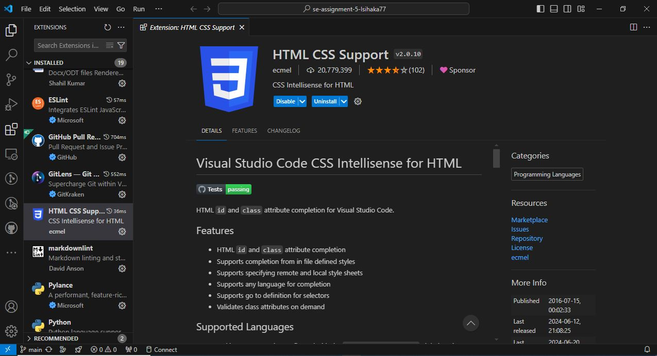

**INTEGRATED TERMINAL**

Advantage of integrated terminal

1. It start at the root of your workingspace
2. Provide integration with the editor to support fetaures like lnk and error detection.

Integrated terminal in vs code can be opened by

1. Click terminal in menu bar and choose new terminal
2. Got to view in menu bar and choose terminal

**FILE AND FOLDER MANAGEMENT**

Explorer is used to browser, open and manage files and folders ini your project. Vs code is file and folder bases and you can start by opening a file or folder in vs code. After opening a folder in vs code the contents of the folder are shown in explorer view.

Things you can do in explorer view

1. Create, delete and rename file and folders.
2. Move files and folder with drag and drop
3. Use context menu to explore all option

Example from file explorer on pc user can drag a file from thre to vs code and drop it to opened repository folder in vs code and a copy of that file will be copied on that directory waiting to be tracked.

**SETTING AND PREFERENCES**

User can find setting by going to file>preferences>setting or opening the setting editor from the command palette “ctrl+shift+p” then type preference: open setting. Vs code offer different kind of setting based on your customization examples

changing theme by following steps

1. Open command palette
2. Type “preference theme” then choose from market place or just colour theme of vs code.
3. Colour theme of your choice

Changing

1. Open command palette
2. Type “font size”
3. Then choose between increase or decrease of different font size of the whole vs code of other view of vs code

Keybord shortcut

1. Go to file>preference>keyboard shortcut

Or

1. Using keyboard short command “ctrl+k+ctrl+s” shortcut setting will open then you will set based on your keyboard layout

**DEBUGGING IN VS CODE**

Vs code is being built with debugging support for Node.js runtime and can only debug Javascript, Typescript and other program that are just like javascript. To debug other program a software developer have to install extension that will help in debugging. But vs code has some key debugging feaute available in it

Example:

1. Manually changing values I runtime

These happen by hovering over properties and variable and be ablle to change value of them. But those variables and properties have to be of same type.

1. Immediate window

Theseis great tool in vs code that help in debugging can able to call other tools that help in debugging.

1. Watcher

These useful tool help in keeping track of variables as well as dissect them and be able to add any variable to it and automatical load all its values. As a programmer debug these tool help mark the variables wich have changed in red to see which one have changed.

1. Conditional breakpoints

These powerful tool can be opened by right clicking on an existing breakpoint and then add condition by configuration.

1. Yellow arrow dragging.

This yellow arrow indicates which is the next piece of code that is going to be executed, but these yellow arrow can be dragged around the code. To give user which line of code he/she want to debug fast.

1. Call stack

These help software developer to know where he end up on debugging. Example by double cricking on a call stack can able to check current values of all variables related to the method

**USING SOURCE CONTROL**

Source Control help software programmer to store , manage source code with Github in Vscode, o acces it you have to activity bar and click source control while open the folder in which you store your copy of github repository and click initiliaze repository on source control. if you have a file that isn’t in your online repository, means the file is not tracked “shown with letter U”. To track the file “adding to online repository” you have to click a “+” sign next to the name of the file, the file will be added “shown with letter A”. next step will be to commit the file by adding a message like “this is my first commit” and to submit it I will click a check sign “ $√$” and the fill be have “M” showing the file is already pushed to github repository.